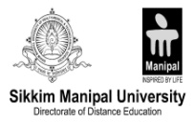

Certificate from University Learning Centre

This is to certify that Mr. Manish Shrestha of B.Sc.IT has worked on the project as per the course curriculum of Bsc.IT/6th Semester. This project entitled “Online Vehicle Reservation” is the original work of Manish Shrestha and was carried out under the supervision of Mr. Aryan Thakur as per the guidelines provided by the university. As per the student’s declaration this is certified that his project has not been presented anywhere as a part of any other academic work.

………………….…………
Prof. Dr. Mahendra Singh
Chief Academic Advisor

………………………
R N Thakur
Centre Head

